**Computer Vision fundamentals**

1. How to represent the Images?
2. How to obtain the features within the image?
3. Gradient of Image

Q- What is computer vision?

A- Science that allows computers to understand images and vedio and determine what the Computer “sees” or “recognizes”

or

Computers understand what happening with in Image

Examples-

Object with in an Image  
Self driving cars pedestrain that has beeb detected if there is a specific lane

**Humans VS Computer see Images**

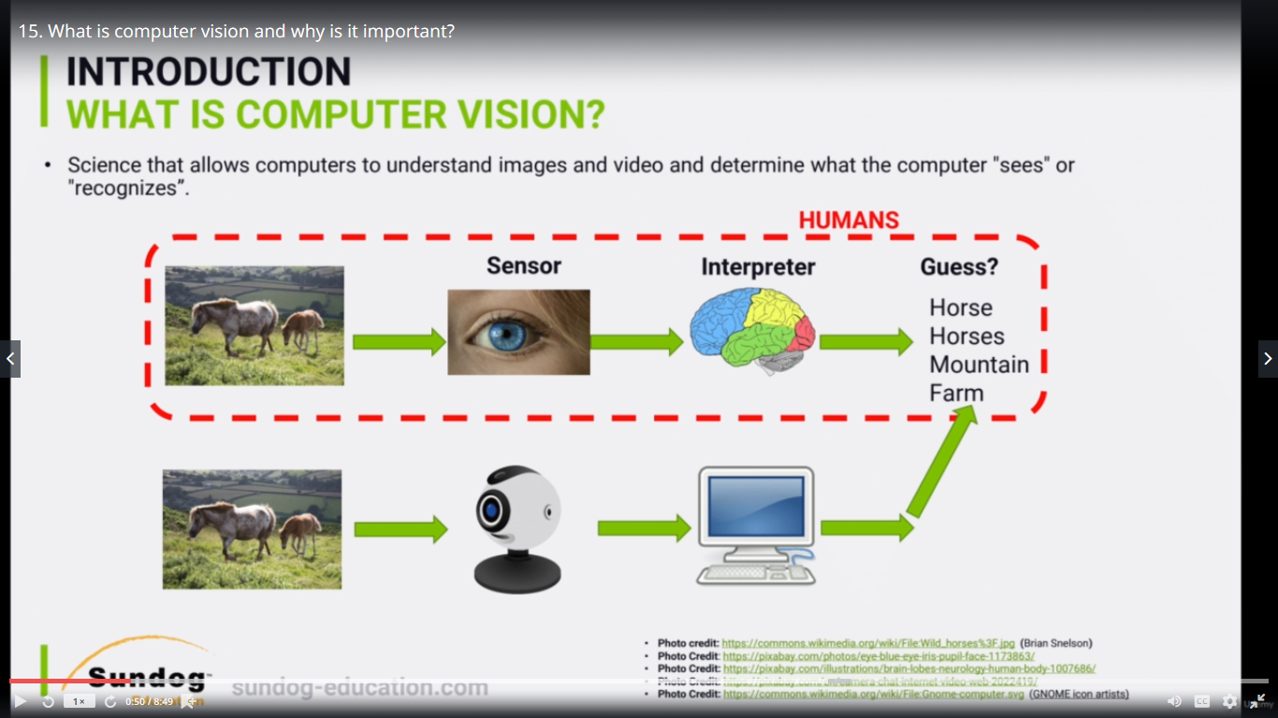

**Why** **Computer Vision is Important?**

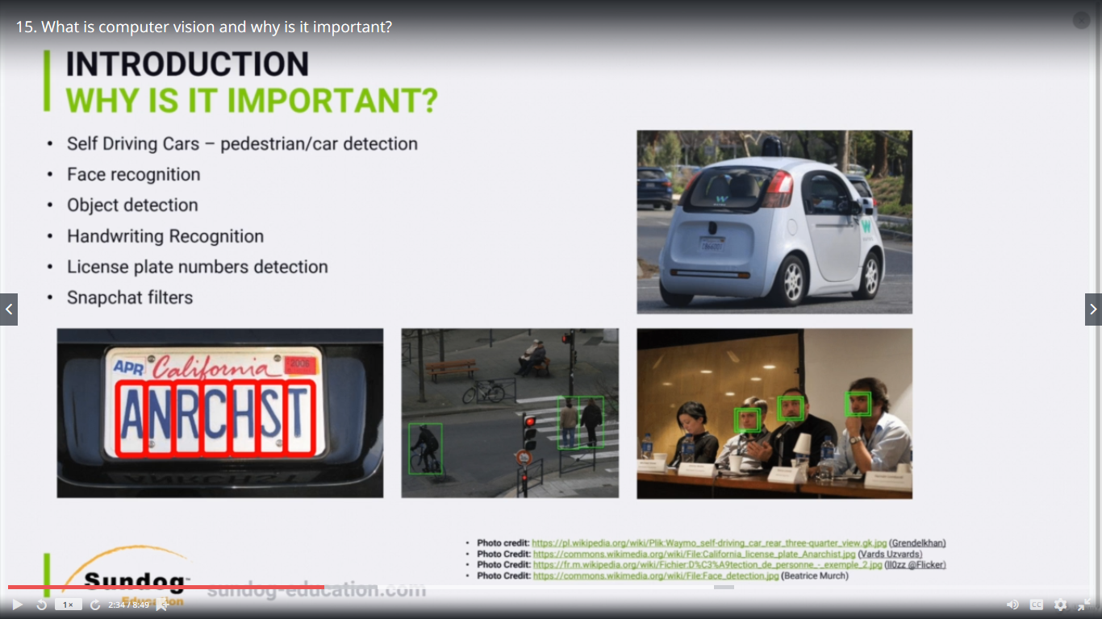

**Why is so challenging?**



classification generalization- red car ort blue car

Human have good generalization understanding skills like car behind the store, red car, blue car etc.

However it's actually very complex task to you know to train computers to actually do it or 10 an algorithm

to actually do it because we need you know if we gonna specify you know based on colors actually we

have so many different colors if we specify for example different lighting here you might see a little

bit darker image for example or maybe this like kind of a smaller image or different scales.

You know there's different orientation of the car.

You know this car from the front from behind and so on.

So that's why it's very difficult actually challenging task to train a computer in the same way that

we actually do as humans.

**Couple of challenges Deeper**

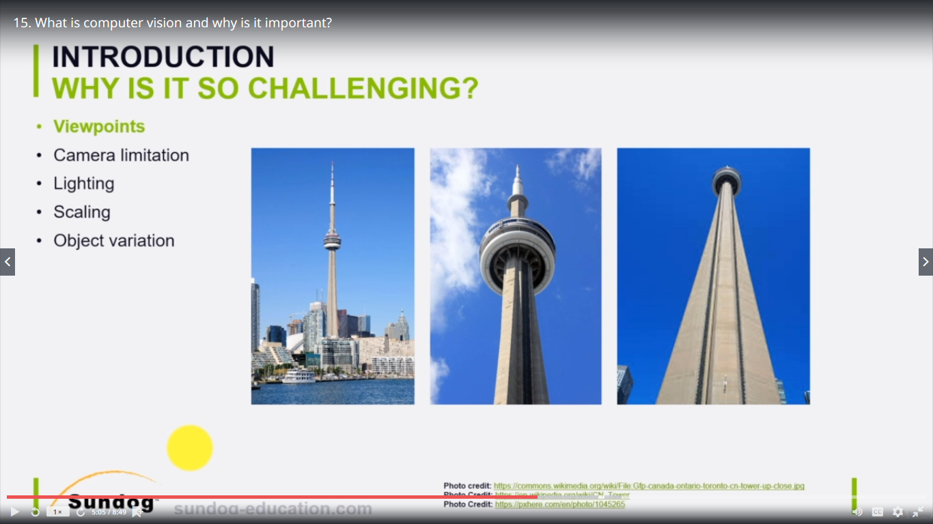

**All right so let's this is kind of an image of the CND tower in Toronto right.**

And this kind of a view you know like from a kind of a faraway that's kind of a seeing tower.

OK.

We can recognize it easily.

However viewpoint if we let's say go underneath the sea and tower and look up.

That's the image we're going to be getting.

Or maybe forget a little bit closer and get like you know kind of more and more kind of angle you get

come up with.

Well that's right.

However these three elements are actually the same object.

However it's very difficult you know to take all these images and let your computer generalize you know

and become way smart from different viewpoints can tell.

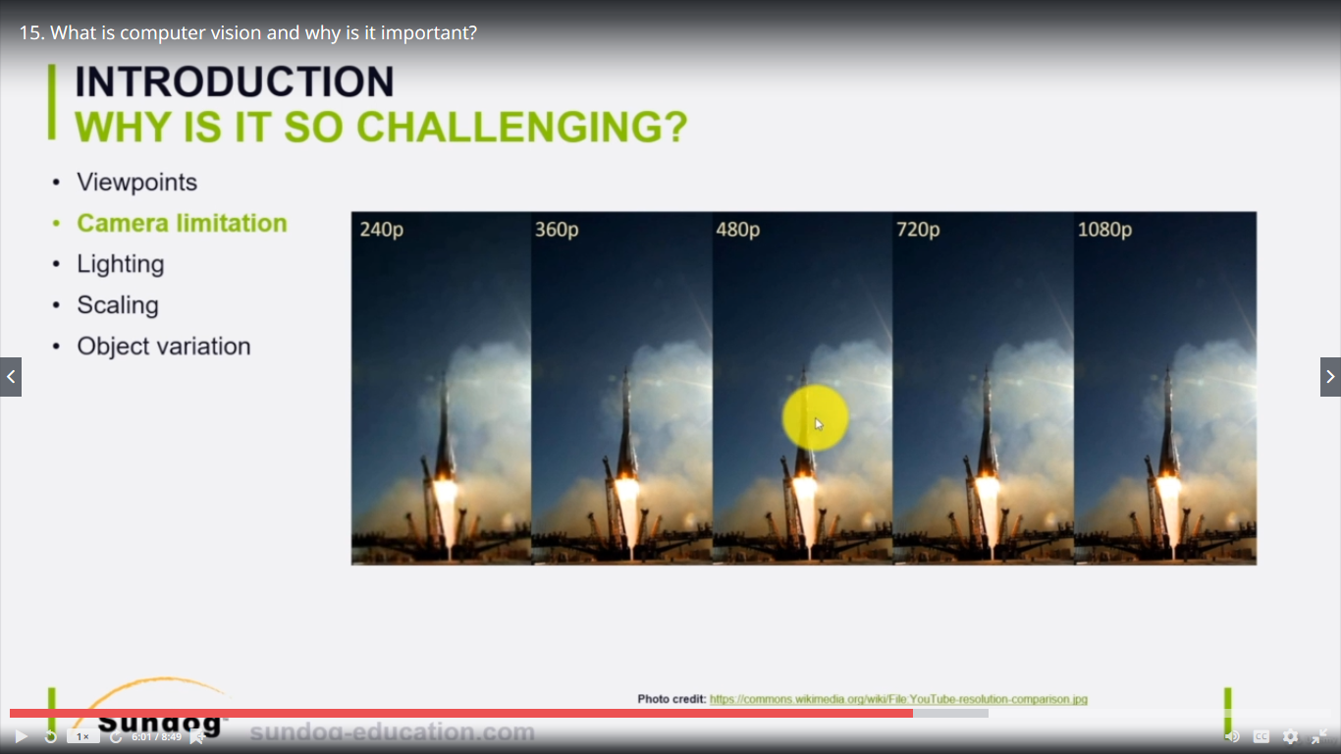

**We good more pixels as resolution is high**

**Example – 1080 resolution got more pixel than 720 pixels**

**Low pixel means image is blure**

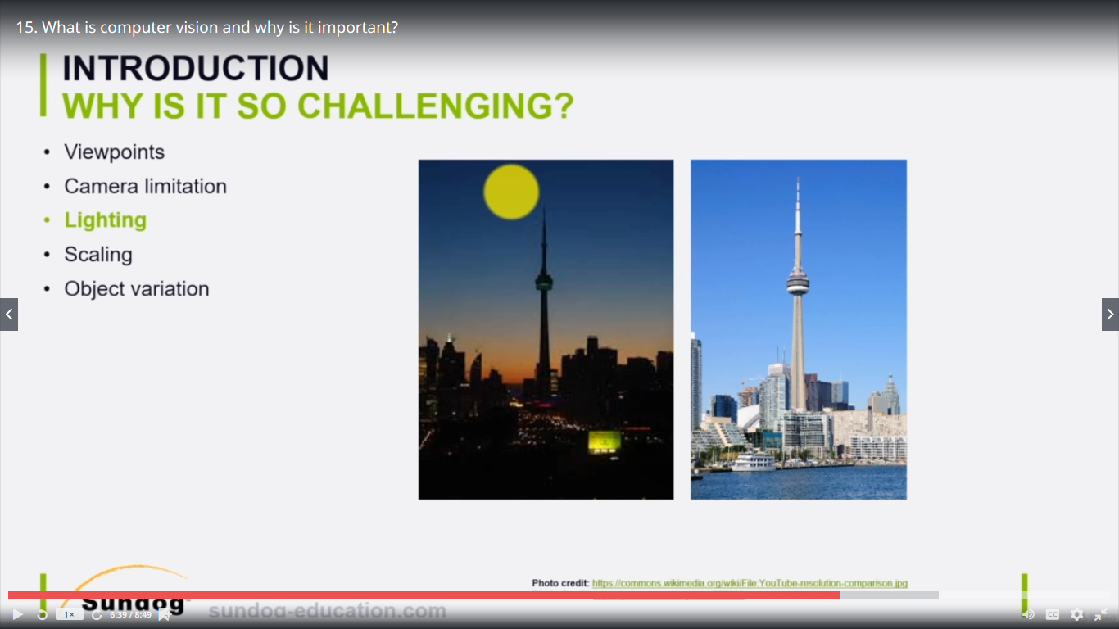

Again here we have our exact same object which we're going to see and power here in the morning in daylight.

You know maybe the machine learning algorithm or the you know computerized computer vision algorithm

can tell us OK this is a seeing tower easy however at night you know if it's a little bit dark you know

the features for us are the same.

However it's a bit difficult for that for the algorithm to actually detect it because you know with

different lighting conditions for example which is the same again for self-driving cars we want our

cars to drive in the morning at night everywhere in snow conditions everywhere and actually detect objects

objects and pedestrians and so on.

All right.

Perfect.

Next step is what we call it killing.

All right.

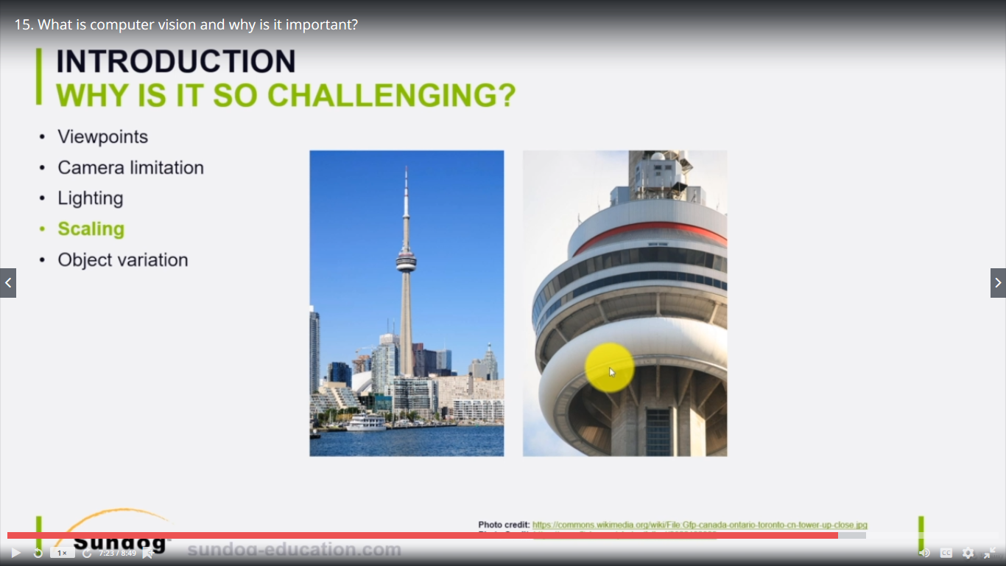

So again here is our object with what if we zoomed in for example to take take an image like this for

instance you know like we if we what if we have for example classifying pedestrians we might have a

long like a tall pedestrian a short one for example how can the machine learning algorithm that can

specify the rate of their all these are pedestrians in all the cars for example if our car is needed

by car.

How can we how can we classify all that.

That's you know the power of of advanced kind of you know computer vision algorithms.

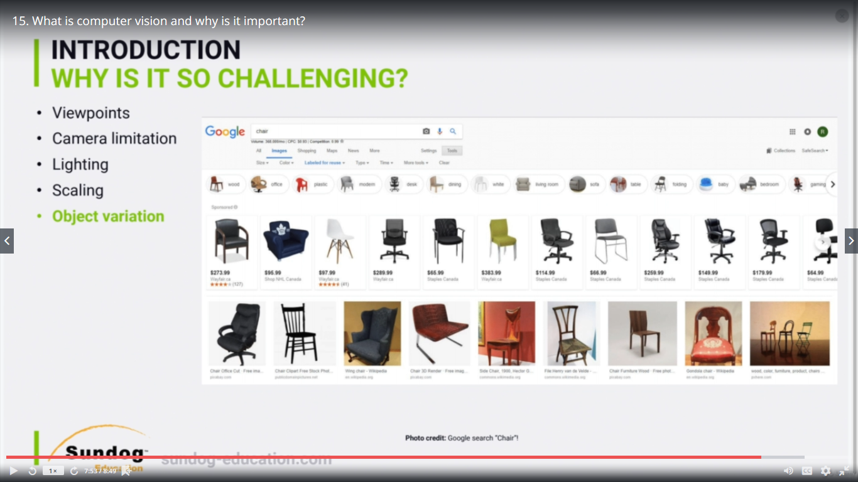

The next step or the last episode called Object variation again I went there and I looked up let's say

when I classify chairs OK that's you know the images of chairs.

So all of them for us you know even if you show it to a kind of a baby he can easily you know classify

these all these are chairs.

OK.

Why again.

Because our brain can easily generalize.

You know it has been knocking over like thousands and hundreds of thousands of images however to train

this you know like to like a machine learning algorithm or computer vision is actually a challenging

task.

All right.

So again we have different object variations so like the actual chair this chair for example looks completely

different than this looks completely different that this is different materials and textures.

That's why it's very difficult to do or very challenging to do computer vision in general in a computerized

fashion.